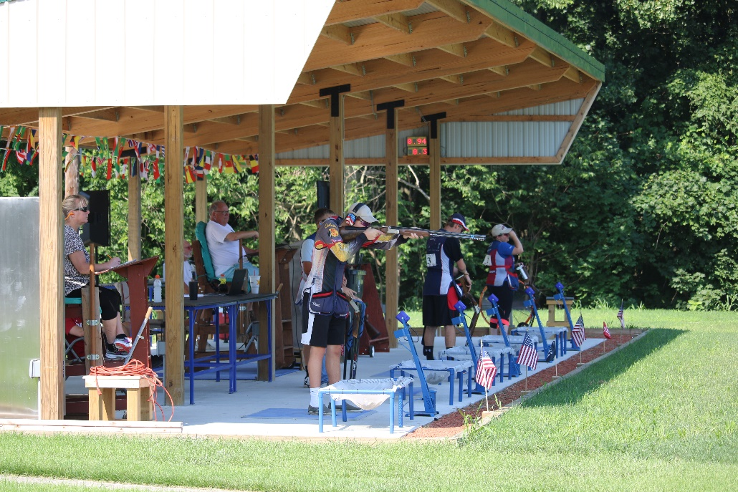
Palmyra International Bunker Season Opening Weekend
2 Days - 2 Events
4/24/2021 Saturdays Event:
Course of fire:
75 Target on Saturday with 50 Target Open Final

4/25/2021 Sundays Event:
Course of fire:
75 Target on Sunday with 50 Target Open Final

Saturdays Event $50.00 and Sundays is $50.00
Cash or Check

Classes
A-B-C-D
Category
Men- Women – Junior
To register email J.Thompson@palmyrasportsmens.com
With any question please call or Text 717-329-2314
About Palmyra International Shotgun Range
The Palmyra International Shotgun Range was built in 2020 with the support of the Midway Foundation and The Friends of the NRA. The facility was designed with the latest available technology to provide all the tools to develop world class shooters. All variables were considered to make sure the range is able to provide the best possible training experience for the developing shooting athletes.
Palmyra International Shotgun Range was built to ISSF/ USA Shooting Regulations. The shooting area is covered and heated as needed. The bunker is equipped with Mattarelli and ELFIPA Electronics and Electronic Scoring. Palmyra is also the first range in the USA to incorporate the Berretta Shooting Data RFID Performance Tracking System to help shooter reach their top potential.
The Palmyra Sportsmen’s Association is Palmyra is easily accessed and is located in the center of the Mid-Atlantic Region With major interstates providing access US76-US83- US81
- Airports:
  - Harrisburg International Airport (MDT) 29 min
  - Philadelphia Intentional Airport (PHI) 1hr 42 min
  - Baltimore International Airport (BWI) 1hr 50 min

- Hotels
  - There are 105 Lodging choices within 10 Miles
- Entertainment
  - Tanger Outlets of Hershey 6 Miles
  - Hershey Amusement Park 7 miles
  - Hollywood Casino and Race Track 8 miles
  - Lancaster Amish Country 35 miles
  - Dutch Wonderland Amusement Park 36 miles
  - Tanger Outlets of Lancaster 37 miles
  - Cabela's Largest Retail Store 42 miles
  - Gettysburg Battlefield 67 miles

